Annual General Meeting (AGM)
19 May 2016
6 – 8 pm

Present: Richard Hudler (Chair), Dwayne Shaw (Vice-Chair), Matthew Beeson, John Wilson (Treasurer), Brian de Matos, Susan Gapka, Rob Teixeira.

Proxy: Nick Mulé, Heather MacNaughton, Jonathan Mackereth With proxy voters that makes a total of 9 voting members, constituting a quorum (7).

The AGM component of tonight’s meeting commences.

AGM Minutes - 2015
Last year’s AGM Minutes Approved. John moved to approve the minutes; Rob seconded. Approved. Passed.

Report from the Chair.
Read out a written report. Rob was very impressed with the work that QO has participated in over the last year.
Susan also sees that QO has been participating in a range of events… Susan moves to accept Richard Hudler’s report and John seconds it. Approved. (See Attachment I)

Treasurer’s report
John circulated a detailed report and Budget.

Brian asked some questions around the expenses for our domain name and website expenses. GSA fund is earmarked for political action around the GSA issue.

Richard moved to approve Treasurer’s reported. Matthew seconded. Approved. (See Attachment II)

Queer Ontario AGM - Election

Statements from the Candidates

a) Vice Chair Statement: Dwayne Shaw. Dwayne wishes to continue in role of vice-chair. QO should have priorities outside the QLT Project but he feels that it was not beneficial to QO as a whole. Dwayne stands strong with the chair and SC and will work to support current and future work and help to enable that process. Dwayne wishes to have people put their faith in Dwayne and continue in his role of vice chair

b) Treasurer. John Wilson. John wishes to continue in his role as Treasurer.

c) Member at Large: Matthew Beeson. Wants to do more bridging with QO in the community and he wants to work to raise our profile and get the community constituents updated on what is going on . So there is more participation and community support and what the community means to me. Continue to serve and work with nick to strengthen our constituents and ourselves.

Robert and Brian were scrutineers and ballot counters.

Election Results
It is customary to retain the ballots for a length of time after the election. All used election ballots were sealed in an envelope; unused ballots were destroyed. Brian moved to retain the marked Ballots for two weeks. Richard seconded the motion to strike (destroy) the ballots on June 2, 2016 -- two weeks after today’s election.

Steering Committee will consider appointing Brian to acting Secretary to help with website renewal and to keep us updated on technical issues. Term is until the next time we can have an election for Secretary. Richard moved and Rob seconded the motion. Approved.

Elections
Candidates John Wilson, Matthew Beeson, and Dwayne Shaw provided oral statements about their work for Queer Ontario in the future.

Election results:

Dwayne Shaw elected to position of Vice-Chair for a 2-year term. (His previous position was as Interim Chair). 19 May 2016 – May 2018.

John Wilson elected to position of Treasure for another 2 – year Term.

Matthew Beeson elected to a position of Member-at-Large. – 2 year Term.

Matthew motions to adjourn the AGM; John seconds. Motion Carried:
Queer Ontario’s Annual General Meeting has been adjourned.

APPENDIX I
CHAIRPERSON’S REPORT
Queer Ontario Annual General Meeting
May 19, 2016

When I ran for Chair last year I was asked what my goals would be for Queer Ontario (QO). I said they were to tow the organization out of the doldrums. That has not been accomplished. I do, however, see some glimmers of hope.

To raise awareness of Queer Ontario we felt we needed to focus on increasing our visibility around the province and addressing viable issues. We made efforts in both directions but our numbers remain low and we are without a secretary.

Efforts to increase our visibility were made by developing a directory of likeminded organizations throughout the province, preparing the Fall 2015 QO Newsletter, conducting a Volunteer Orientation Meeting, participating in a consultation with Daily Xtra, continuing work on the Queer Liberation Theory Project which also involved developing conflict resolution and netiquette guidelines, organizing our archives to be sent to the Canadian Lesbian and Gay Archives, organizing a picnic, joining some Pride Celebrations, working on becoming incorporated and consulting with The 519 about improving technical access to social media in the building. We have been hampered in these efforts by our personal lack of skills in the areas of technology and social media. Our glimmer of hope is that going forward we have people with these skills interested in helping us.

In terms of addressing viable issues, Queer Ontario supported the “We Demand an Apology Statement”, the Ontario Coalition Against Poverty concerns about police activity in disadvantaged neighbourhoods during the Pan Am games, an Education Day by the Ontario Public Service Employees Union, a Sex Education Curriculum rally, efforts to address issues around sex laws and sex work and concerns about Bill C-51 and the possible criminalization of dissent on the part of the Federal Government. A written and verbal deputation was made in support of Bill 77, “Affirming Sexual Orientation and Gender Identity” which was passed. A written deputation was presented to the City of Toronto Executive Committee regarding proposed Revitalization of George Street and we organized and/or participated in meetings concerning the Moss Park Project, potential closing of Fudger House and the city’s Strategy on Poverty. Regarding Human Rights, we endorsed the Canadian HIV/AIDS Legal Network call to action for Global LGBTI Human Rights, communicated with the Ontario Human Rights Commission regarding their new strategic plan, attended the launch of the report “Envisioning LGBT Refugee Rights in Canada: Is Canada a Safe Haven?” and participated in a roundtable on gender identity issues with the Canadian Human Rights Commission.

Queer Ontario is attempting to carry on a concept of liberation that goes beyond equality. We want to ensure there is room for diversity in society that goes beyond assimilation. That goal requires that we also be able to ensure there is room for diversity among ourselves. Not just in terms of geography, race, ability, social status and the many other measures of difference but also in our ways of thinking and functioning so long as we continue to agree on that basic concept of liberation.

This effort is not easy for all of society or for us. We have to set an example. Despite our differing personal interests and goals we are all capable of contributing to that concept of liberation and we must look for ways to support each other to pursue our interests and goals individually and collectively.

Richard Hudler

APPENDIX II

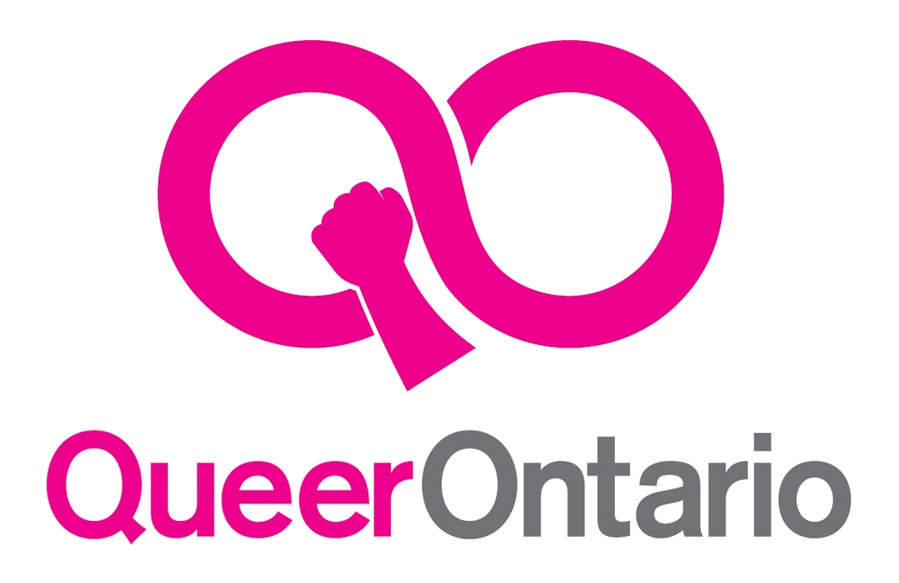
QO PROPOSED BUDGET April, 2016
Fiscal year April 1 – March 31
ACCOUNTS | Beginning 15/16 | Beginning 16/17
Chequing | 1,363.97 | 4,584.05
Savings (GSA fund) | 435.54 | 435.73
Pay Pal | 1,749.12 | 2,061.69
TOTAL | 3,548.63 | 7,081.47

INCOME | Budget 15/16 | Actual 14/15 | Budget 16/17
Donations Chequeing | 3,200 | 3,419.65 | 300
Donations Pay Pal | 360 | 485.00 | 360
Workshops | 0 | 0 | 0
Bank | 1 | 1.83 | 0
Grants/projects | 0 | 91.95 | 0
Grant seed money | 0 | 0 | 0
Miscellaneous | 0 | 0 | 0
TOTAL | 3561 | 3,998.43 | 660

EXPENSES | Budget 15/16 | Actual 15/16 | Budget 16/17
Meeting Expenses | 50 | 9.00 | 50
Office Supplies | 50 | 0 | 30
Printing/Copying | 700 | 79.10 | 100
Transportation | 0 | 0 | 0
Postage | 50 | 0 | 0
Grants | 0 | 0 | 0
Projects | 400 | 203.46 | 250
Bank | 0 | 1.60 | 0
Pay Pal Fees | 25 | 21.99 | 30
Promotion/Advertising | 100 | 0 | 0
Web | 750 | 150.44 | 200
Misc. | 0 | 0 | 0
TOTAL | 2125 | 465.59 | 660
Less Income | 3561 | 3,998.43 | 660
Balance | 1436 | 3.532.84 | 0
Assets: Table, Megaphone, Snowball mike, Gazebo, Gazebo cart.
John Wilson, Treasurer
FINANCIAL REPORT – AGM 2015/2016

- We have maintained three financial accounts during the past year:
  - A Chequing Account at Alterna Savings where our day to day transactions take place.
  - A Savings Account at Alterna Savings which is specifically earmarked for the Gay Straight Alliance (GSA) Defense Fund.
  - A Pay Pal Account where we receive our monthly and other electronic donations and from which some of our electronic payments are made e.g., website internet payments.

- Spreadsheets were kept for the fiscal year from April 1st to March 31st.

- Detailed spreadsheets are available for anyone who wants to look at them.

- The Budget reflects only the budget for the previous year, actual income and expenses for the previous year, and the budget for the New Year.

- I would also remind members that the Queer Liberation Theory Project, in which Queer Ontario is a community-based partner on this academic research study, has been financed primarily by four internal research grants from York University for a total amount of $10,380.00 and those funds did not go through the Queer Ontario books. The QLT Project received an additional $2,000.00 from the Inside Out/OUTtv Post-Production Fund but was issued directly to the QLT Project's principal investigator.

- In terms of the Annual Review of the Books, it was suggested last year that we not incur the expense of auditors at this time and simply ask a volunteer from the membership, who has not been involved with the bookkeeping, to review the books at the fiscal year end.

- I suggest that we repeat that procedure again this year.

- This involved looking at the books for any discrepancies or clarifications and randomly selecting several income and disbursement entries to see if the receipts and match up with the entries.

- I wish to thank Dwayne Shaw for volunteering to provide this service and who submitted the following report:

- Budget:
ANNUAL REVIEW OF QUEER ONTARIO
FINANCIAL RECORDS
2015/2016 Fiscal Year

I have reviewed the financial records of Queer Ontario (QO) which comprise the spreadsheets, the bank statements, the receipts file, the donations file, the Pay Pal file, the GSA Defense Fund file and the draft Budget.

These documents were provided by the Treasurer of Queer Ontario. I am a member of Queer Ontario and undertook this review as a volunteer who was not involved with the bookkeeping.

My review involved looking at the books for any discrepancies or clarifications and randomly selecting income and disbursement entries to see if the receipts and documents match up with the entries.

In my opinion, the financial records present fairly, in all material aspects, the financial position of Queer Ontario as at March 31, 2016.

Dwayne Shaw

These donations are earmarked for the GSA defense fund.
Bequest – No bequest anticipated for 2016/17
Monthly donations
200 regular for budget, 500 for the directory – We decided not to print the directory
150 regular for budget, 500 for improved communication with Province equipment – Our efforts did not materialize.

